**EX.NO:1 AUDIO EDITING TASK**

**IMPORT AUDIO:-**

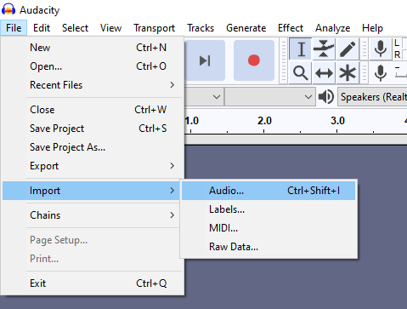

**FADE IN:-**

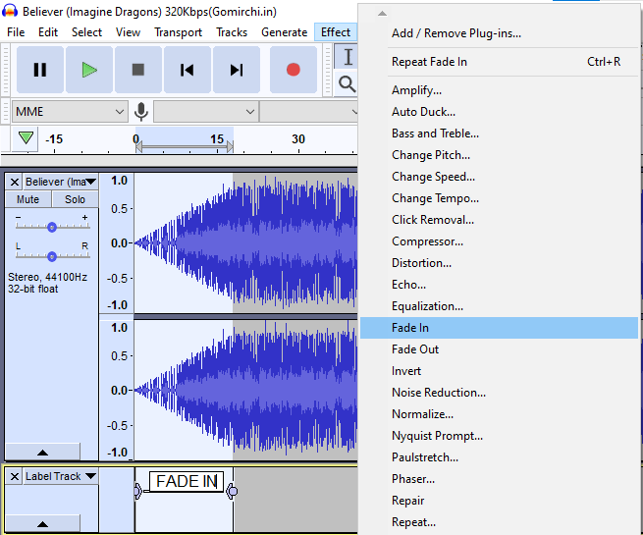

**FADE OUT:-**

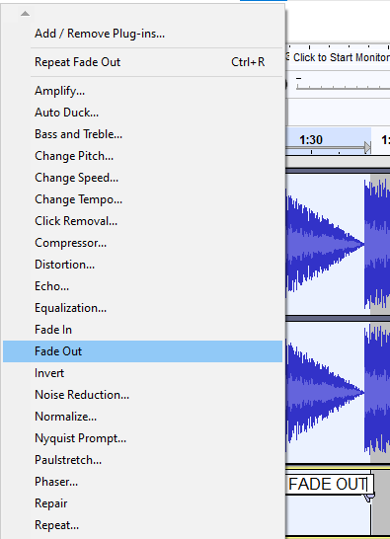

**NOISE REDUCTION:-**

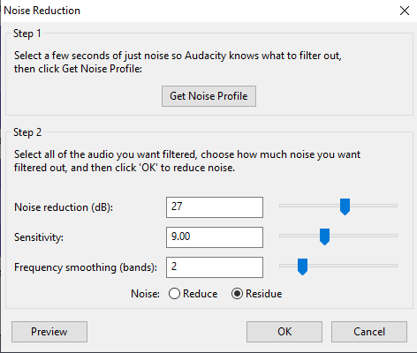

**AMPLIFY:-**

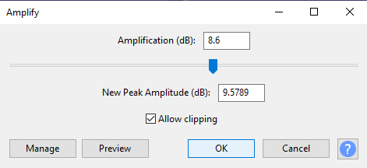

**LESS & HIGH AMPLIFY:-**

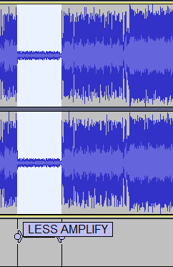 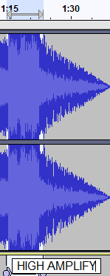

**MIX TO RENDER AND STEREO DOWN TO MONO:-**

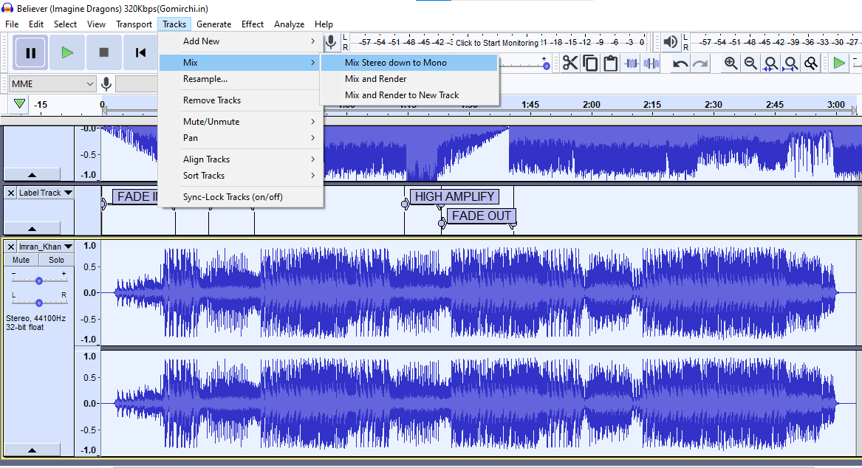

**ADD LABEL:-**

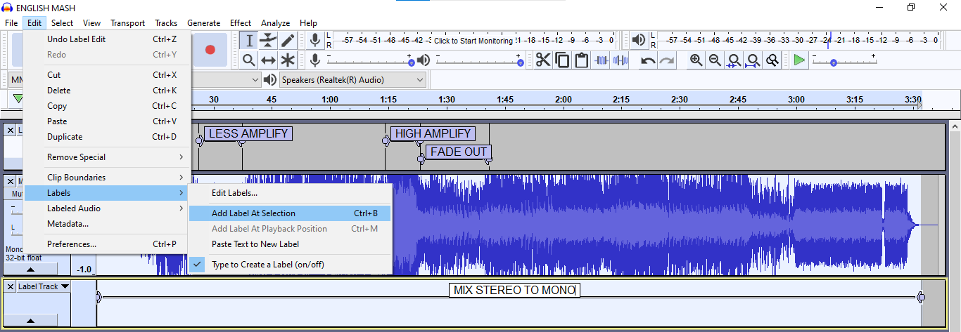

**OUTPUT:-**

